**Growth disturbance:**

Which classified into:

**I- Developmental defect:** include

**1- *Agenesis*:** Means complete absence of an organ*.*

***2- Aplasia*:** Means complete failure of organ to grow (failure of development).

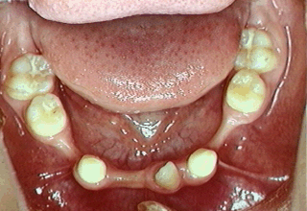

**Dental Aplasia**

**3- Hypoplasia**:Its mean failure of an organ to reach normal size, which occupies the spectrum between aplasia and normal development for example renal hypoplasia and testicular hypoplasia.

Histological feature presence of immature or embryonal tissue as a result of interruption in differentiation to normal mature cells.

**II- Acquired defect:** which included**:**

**1. Atrophy**

**2. Hypertrophy**

**3. Hyperplasia**

**4. Metaplasia**

**5. Dysplasia**

**1. Atrophy**: Its mean decreased size of an organ or tissue after it has achieved normal size caused by loss of cells (necrosis) or decreased cell size (cellular atrophy).

The tissue or organ atrophy resulting from reduction in individual cell size is an adaptive response to altered demands on the cell, often a reduction in work load.

**Causes of atrophy:**

**1.** A reduction in work load (disuse atrophy)**.**

**2.** Loss of innervation (denervation atrophy)**.**

**3.** Loss of hormonal stimulation**.**

**4.** Reduced blood supply (ischemia).

**5.** Inadequate nutrition**.**

**6.** Aging (senile atrophy)**.**

**7.** Pressure.

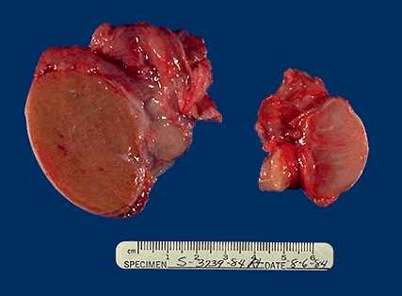

**Testicular atrophy**

**2- Hypertrophy:**

Hypertrophy is an increase in the size of cells resulting in increase in the size of the organ.

The pure hypertrophy there are no new cells, just bigger cells containing increased amounts of structural proteins and organelles.

Hypertrophy can be physiologic or pathologicand is caused either by increased functional demand or by growth factor or hormonal stimulation.

The massive physiologic enlargement of the uterus during pregnancy occurs as a consequence of estrogen stimulated smooth muscle hypertrophy and smooth muscle hyperplasia.

In contrast, in response to increased demand the striated muscle cells in both the skeletal muscle and the heart can undergo only hypertrophy because adult muscle cells have a limited capacity to divide. Therefore, the chiseled physique of the avid weightlifter stems solely from the hypertrophy of individual skeletal muscles.

An example of pathologic cellular hypertrophy is the cardiac enlargement that occurs with hypertension or aortic valve disease.



Physiologic hypertrophy of the uterus during pregnancy

**3- Hyperplasia:**

Hyperplasia is characterized by an increase in cell number because of proliferation of differentiated cells and replacement by tissue stem cells.

Hyperplasia can be physiologic or pathologic. In both situations, cellular proliferation is stimulated by growth factors that are produced by a variety of cell types.

• The two types of physiologic hyperplasia are (1) *hormonal hyperplasia,* exemplified by the proliferation of the glandularepithelium of the female breast at puberty andduring pregnancy, and (2) *compensatory hyperplasia,* in which residual tissue grows after removal or loss of partof an organ. For example, when part of a liver is resected,mitotic activity in the remaining cells begins as early as12 hours later, eventually restoring the liver to its normalweight. The stimuli for hyperplasia in this setting arepolypeptide growth factors produced by uninjuredhepatocytes as well as non parenchymal cells in the liver*.* After restoration of the liver mass, cell proliferationis “turned off” by various growth inhibitors.

• Most forms of *pathologic hyperplasia* are caused by excessive hormonal or growth factor stimulation. For example, after a normal menstrual period there is a burst of uterine epithelial proliferation that is normally tightly regulated by stimulation through pituitary hormones and ovarian estrogen and by inhibition through progesterone. However, a disturbed balance between estrogen and progesterone causes endometrial hyperplasia, which is a common cause of abnormal menstrual bleeding.

**4. Metaplasia:** Its mean an adaptive response in which one type of mature differentiated cell is replaced by a another one, the metaplasia does not occur as the result of alterations in existing mature cells, but it depends on proliferation of germinal, or stem cells whose progeny undergo modified differentiation.

**Examples of metaplasia:**

**1.** Columnar to Squamous epithelial metaplasia:

Like : Respiratory tract in habitual cigarette smokers and excretory ducts of salivary glands, pancreas and bile ducts with stones**.**

**2.** Squamous to Columnar epithelial metaplasia:

Like: The esophagus under influence of refluxed gastric acid, so-called Barrett esophagus.

3. Fibrous tisssue to Osseous or Cartilagenous metaplasia:

Like: Myositis ossificans.

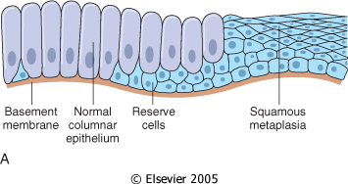**Squamous Metaplasia**

**5. Dysplasia:**

Dysplasia means ‘disordered cellular development’, often accompanied with metaplasia and hyperplasia; it is therefore also referred to as *atypical hyperplasia*.

Dysplasia occurs most often in epithelial cells. Epithelial dysplasia is characterised by cellular proliferation and cytologic changes. These changes include:

1. Increased number of layers of epithelial cells.

2. Disorderly arrangement of cells from basal layer to the surface layer.

3. Loss of basal polarity like nuclei lying away from basement membrane

4. Cellular and nuclear pleomorphism

5. Increased nucleocytoplasmic ratio.

6. Nuclear hyperchromatism

7. Increased mitotic activity.

The two most common examples of dysplastic changes are the *uterine cervix* and *respiratory tract*.

Therefore, Dysplasia is defined as neoplastic epithelium that remains confined within the basement membrane of the epithelial surface within which it arose.

**Uterine dysplasia**